Figure 1
Modern Art Museum
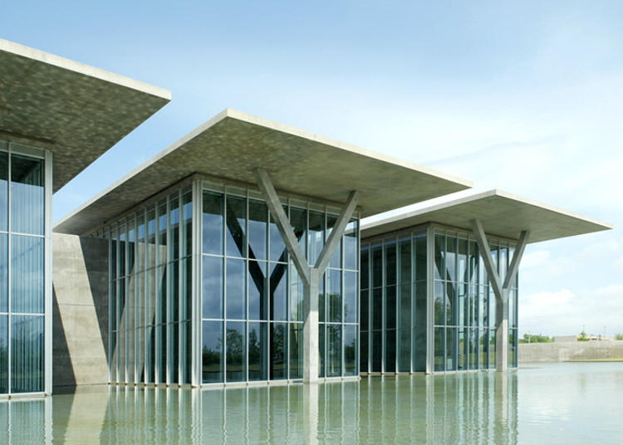
From Modern Art Museum, by L. Yousheng, 2002,
(https://www.archdaily.com/213084/flashback-modern-art-museum-of-fort-worth-tadao-ando) Copyright by L. Yousheng

How did Tadao Ando’s manifesto of combining light and concrete reflect

in the Modern Art Museum Fort Worth project?

Olivera Pesic (899 words without references)
Bachelor of Building Surveying, Victoria University
(NBD 1100) Built Environment Communication and Skills - ORT, F
Shiran Geng PhD
05/06/2023

The 153,000-square-foot Fort Worth Modern is the largest Museum of postwar art in the U.S. after New York’s Museum of Modern Art. The building sits on an 11-acre site at the edge of Forth Worth a city in Texas (Dillon, 2003). This case study explores how the famous architect Tadao Ando built his vision of combining light and concrete into this contemporary construction. The selection of Tadao Ando’s generous, serene design signaled an ambitious determination to meet the challenge, the wisdom of the choice being revealed when the Modern opened in December 2002 (Craft, 2003). Wo-Young (2012) quotes Ando’s statement that the world’s population increases and the demand for natural resources surges. Therefore, architects need to create sustainable buildings that last more than 100 years (Wo-Young, 2012)

Firstly, Tadao Ando is an autodidactic architect who obtained his architectural knowledge from Japanese traditional culture but also studied the works of famous architects from Europe and America such as Le Corbusier, Alvar Alto and Mies van der Rohe (Trisnor & Trianto, 2021). Understanding that, Ando pays attention to details and the accuracy of the details, until when he finishes his work, which ensures the high quality of his creation (Trisnor & Trianto, 2021). The incredible challenge in this specific case was to meet the standards of the existing old Kimbell Art Museum's 1972 building. It was designed by Louis I. Kahn and is widely regarded as one of the outstanding architectural achievements of the modern era and located right across the street. In addition, Ando repeatedly said at the opening that he hoped to rise to the same level as Kahn and “to create a link with a great work that is already present” (Dillon, 2003).

Ando envisioned for this Museum a building within a building: an outer, three-story glass curtain wall that would be shaded from the Texas sun by sweeping roof overhangs and would surround massive inner gallery walls of architectural concrete (Morant, 2003). Despite the fact that the forty-foot-high structure, sheathed in anodized aluminium panels, seems anonymous when seen from the sides and a busy street. Additionally acknowledging, the process of anodizing aluminium, which does not only make the aluminum more durable, but also ensures its recyclability, as no extra material is added to the surface (Juhl, 2021).

Five long, flat-roofed pavilions appear to float atop the 1.5-acre shimmering pond, reminding of existing projects. Constructed with his key materials concrete, steel, aluminum, glass and granite, the museum is perfectly reflected in the surrounding pond (Morant, 2003). As seen in Figure 1, the immense concrete roof overhangs, supported by Y-shaped columns on the east side to help shade interior spaces surrounded by 36-foot glass curtain walls constructed with energy efficient insulated glass units, proofing again the connection of the central idea to connect light with concrete. Furthermore, the use of low-e laminated glass for the glass curtain walls is a great option as it does not minimize or alter sunlight and therefore benefits thermal insulation and solar control, surpassing the capabilities of conventional clear float glass. The play of light shows especially at night when the glass pavilions glow like enormous Japanese lanterns.

As visitors approach the main entrance, aluminium gives way to glass, through which is glimpsed the light-filled interior and the panorama of the man-made pond. Analysing the interior, we find poured concrete walls functioning as a structure within a structure, giving form to the pavilions and the galleries they contain (Craft, 2003).

The polished concrete provides the perfect surface for registering the quicksilver reflections of light as it flickers across the pond's surface. In many buildings light is deployed impassively as a means of articulating volumes, but Ando also uses it here to modulate one's sense of gravity: the experience of being both inside and outside, of floating and of heaviness (Trisnor & Trianto, 2021).
With 53,000 square feet (about half the area of a Manhattan city block) of gallery space, the new building provides more than five times the space of its predecessor, and considerable efforts have been made to ensure that its contents are worthy of its home (Craft, 2003). The space was designed with a system of filters, louvers, and skylights to bring daylight without damaging the art. Above the grand staircase sits the vaulted ceiling, which consists of a layer of stretched translucent fabric with a filter above to distribute light evenly around the vault. As a result, it accommodates large works of art and offer a range of settings, from self-contained spaces to ones that open onto big views of the garden and reflecting pool (Dillon, 2003).

Taking everything into consideration, Tadao Ando proofed his manifesto again and despite challenges, stood strong alongside the Kimbell Art Museum design. In conclusion, he responded to the openness and grand scale of the Texas landscape with an expansiveness of his own (Craft, 2003). I admire the simplicity, focus on nature and sustainable design of this project.

References
Buchanan, P. (2004). TUNED INSTRUMENT. The Architectural Review, 215(1288), 46-53.
https://www.proquest.com/trade-journals/tuned-instrument/docview/201220814/se-2
Craft, C. (2003). The Modern Art Museum of Fort Worth. The Burlington Magazine, 145(1201), 263–264.
https://www.jstor.org/stable/3100664?
Dillon, D. (2003). Tadao Ando brings his concrete-and-glass poetry to the Texas plains at his new MODERN ART MUSEUM OF FORT WORTH. Architectural Record, 191(3),
https://discovery.ebsco.com/c/6kr4lr/viewer/html/xtvgk4r6pv
Juhl, D. (2021). The Importance of Pre-Treatment in Anodizing. Light Metal Age, Vol. 79,
No. 3, pp. 30-32.
https://www.lightmetalage.com/news/industry-news/surfacefinishing/why- anodizing-is-the-most-sustainable-surface- treatment-for-aluminum/
Maruyama, H., & Ando, T. (1994). Interview with Tadao Ando. ANY: Architecture New York, 6, 10–19.
https://www.jstor.org/stable/41845653
Morant, R. (2003). Boxing with light: Tadao Ando’s new museum at Fort Worth both learns from Kahn’s great
Kimbell and copes with the scale and nature of contemporary art. The Architectural Review, 213(1278), 32.
https://www.proquest.com/docview/201202013?accountid=14844
Soraya Masthura Hassan. (2017). Prinsip Desain Geometri Arsitektur Tadao Ando. Emara:
Indonesian Journal of Architecture, 3(2), 77–90. https://doi.org/10.29080/emara.2017.3.2.77-90
Teinert, J. (2004). Surprising Fort Worth: Culture in Cowtown. Microwave Journal, 47(5), 48–60.
https://www.proquest.com/docview/204962523?accountid=14844
Trisno, R., & Lianto, F. (2021). Lao Tze and Confucius’ philosophies influenced the designs of Kisho
Kurokawa and Tadao Ando. City, Territory and Architecture: An Interdisciplinary Debate on Project
Perspectives, 8(1). https://doi.org/10.1186/s40410-021-00138-x
Wo-Young, L. (2012). Creating sustainable buildings to last a lifetime. The Korea Herald.
https://www.koreaherald.com/view.php?ud=20120920000753
Yousheng L. (2002). Museum of Art [Image]. Archdaily
(https://www.archdaily.com/213084/flashback-modern-art-museum-of-fort-worth-tadao-ando) Copyright by L. Yousheng

